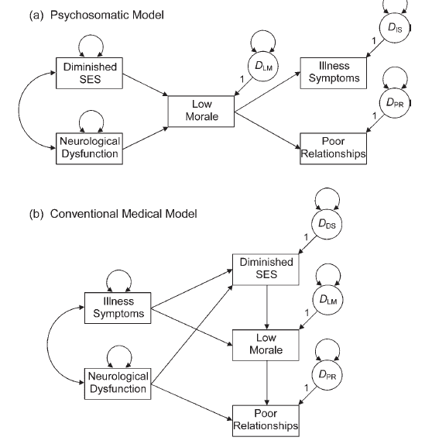

Create model A in Amos.

Cut and paste model A into this document.

Create model B in Amos.

Cut and paste model A into this document.

Include the fit indices for model A and B.

|  |  |  |
| --- | --- | --- |
| Index | Model A | Model B |
| Chi-square (df) |  |  |
| RMSEA |  |  |
| SRMR |  |  |
| CFI |  |  |
| TLI |  |  |
| NFI |  |  |
| AIC |  |  |
| ECVI |  |  |

How are the fit statistics? Would you consider this a “good” model?

Which model appears to be better based on the non-nested fit statistics?